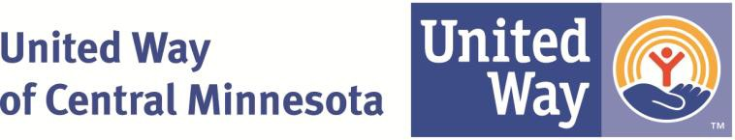

Job Title: Community Impact Intern Department: Community Impact Status: Unpaid
Immediate Supervisor: Community Impact Coordinator
Education: Currently attending college or wanting job experience
Job Related Experience: None required
Physical Requirements: Ability to lift up to 25 lbs and occasionally up to 50 lbs

Basic Job Summary:
United Way of Central Minnesota is focused on creating measurable results in the areas of Health, Education and Financial Stability. We seek a motivated, self-starter with an interest in non-profits and making a positive impact in the community.

Responsibilities
- Participate in one or more of our Impact Areas of Health, Education or Financial Stability
- Organize and participate in volunteer activities impacting the community
- Participate in community initiatives such as Partner for Student Success
- Assist with planning special events
- Conduct targeted outreach to increase awareness of United Way initiatives
- Work with community teams to organize educational trainings dealing with current issues.
- Volunteer two to three hours weekly through a local agency as part of the internship experience.
- Participate in agency-wide staff meetings and department meetings.
- Perform other tasks as assigned

Commitment
This internship has a time commitment of 15-20 hours per week during regular business hours. A specific schedule will be confirmed with the intern upon selection.

Qualifications
- Interest in the non-profit sector
- Punctuality and dependability
- Strong communication skills
- Able to work under deadlines
- A commitment to professional ethics and ability to handle sensitive and confidential information

Benefits
- Hands-on training and close collaboration with a leading non-profit in a positive work environment
- Opportunity to make contacts in the community and acquire experience that is great on your resume
- Reference letter will be provided upon request
- A chance to further develop your talents

How to Apply

Please submit resume and cover letter to:
Amy Trombley, Vice President of Education 3001 Clearwater Rd, suite 201
atrombley@unitedwayhelps.org St. Cloud, MN 56301
320-229-3512 www.unitedwayhelps.org

